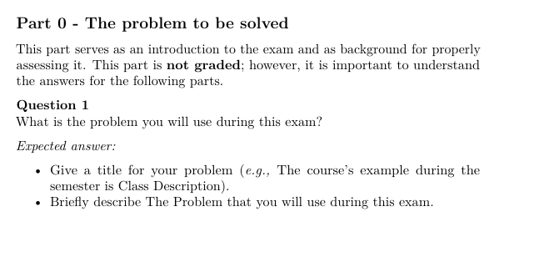
Question 1
- Title: State machonk
- The Problem: A DSL that can be used to create layered state machines. This should make it possible to use state machines to describe complex behaviors in video games.

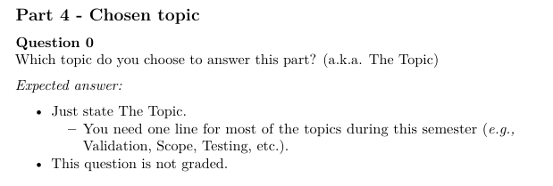
Question 0
- Validation of the state machine. Transitions should only be between states in the same state amchine. That is, the same layer.

